Text «Bats»

Bats are strange creatures: they have legs and feet but they cannot walk. So, they fly like birds and they are the only animals that can fly.Bats are most common in the tropics, where they can find food all the year round. Most bats are brownish in colour, but others are blackish, orange, grey, greyish green, greenish white, white, yellowish, and some are even spotted.
There are fruit-eating bats and insect-eating bats. There are also bats that catch and eat small fish. And there are bats that feed on blood.
Vampire bats are the only animals that feed on blood. These small tailless creatures live in Central and South America. With their two sharp upper teeth vampire bats make a small hole in the skin of another animal and suck blood from it. They sometimes bite human beings, too, but it happens very seldom. The wound they give their victims heals quickly, but these bats may carry rabies, that is why people are afraid of them.
Bats are usually active at night, when most people are asleep. In the daytime they hang close together in their attics, caves, or other dark places where they make their homes.
Bats hang upside down when they are resting. Only when evening comes do they begin to move. They go out of the hole into the night above to search for food. In the morning they come home from their night of work to sleep until the next night.
Bats have very few enemies. Some hawks, owls, and snakes can catch them, but it isn’t an easy thing for them.
Bats live as long as 10 years, some species live longer. Many strange and false legends have been told about bats. In Western countries people fear them and think that they bring bad luck. In China and Japan bats are symbols of good luck, happiness, and long life.



History of banking
Banking has a long tradition. In Mesopotamia bankers kept gold and silver for people and lent it to others. Ancient Rome and Greece had similar banking systems to the ones we have today.
During the Middle Ages Italy was the centre of European banking. Jewish traders emerged as the first bankers and became very successful businessmen. Florence and Venice became known as two cities in which many people earned their money through banking. The Medici family dominated Florence for over two centuries and set up Europe’s largest bank in the 15 th century.
The first world wide banking crisis emerged during the Great Depression in 1929. Many citizens lost their jobs and their savings as banks crashed. In 1933 American president Franklin D. Roosevelt signed a bill in which the government guaranteed the savings of depositors if a bank went bankrupt.
In 2008 a banking crisis hit America and spread throughout the world. Banks gave homeowners mortgages without checking their financial backgrounds. House prices began to drop and banks lost a lot of money. Governments in many countries had to give them money and prevent them from becoming bankrupt.

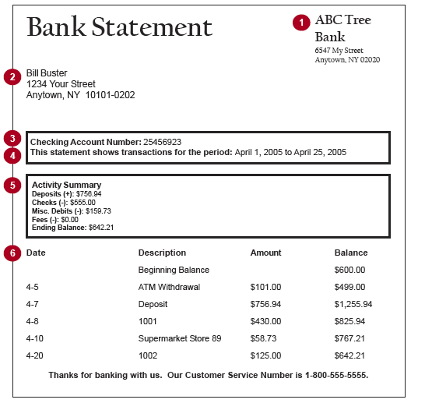

11+ MATHEMATICS SAMPLE PAPER
60 minutes
Equipment Required: Pencil and pen
Special Instructions: All working must be clearly shown and must be set out in the space provided. Attempt as many questions as you can, in any order.
Calculators may not be used.

- Write the number thirty thousand eight hundred and five in figures.

Answer …………………………………… [1]

- Write the number 602 174 in words.

Answer ………………………………………………………………………………..................................
…………………………………………………....................................... [1]

- Nicole downloaded 6 MP3 albums. Each album cost £8.98 and contained 13 tracks.

  - How many tracks did she buy?

Answer …………………………………… [1]

  - How much did she pay in total?

Answer …………………………………… [1]

- 37 girls are going to a Netball Tournament with 6 adults. Each mini bus holds 17 people. How many minibuses are needed?

Answer …………………………………… [3]

- Alice’s train leaves at 16:05. She must allow 1 hour and 12 minutes to get to the station. When is the latest she can leave home and still catch the train?

Answer …………………………………… [2]

